USER GUIDE
Project:
EARTH SCAPE CLIMATE PREDICTION
AERIS
Student Name | Student Enrollment
MUHAMMAD KAARIM HUSSAIN | Student1434937
MUHAMMAD ARHAM KHAN | Student1436820
MUHAMMAD ASIM | Student1438944
LAIBA ALI | Student1439028
SUNDUS KHALID KHAN | Student1457819
UBAIDULLAH | Student1435101

FACULTY: Sir Owais Khan

HOME PAGE
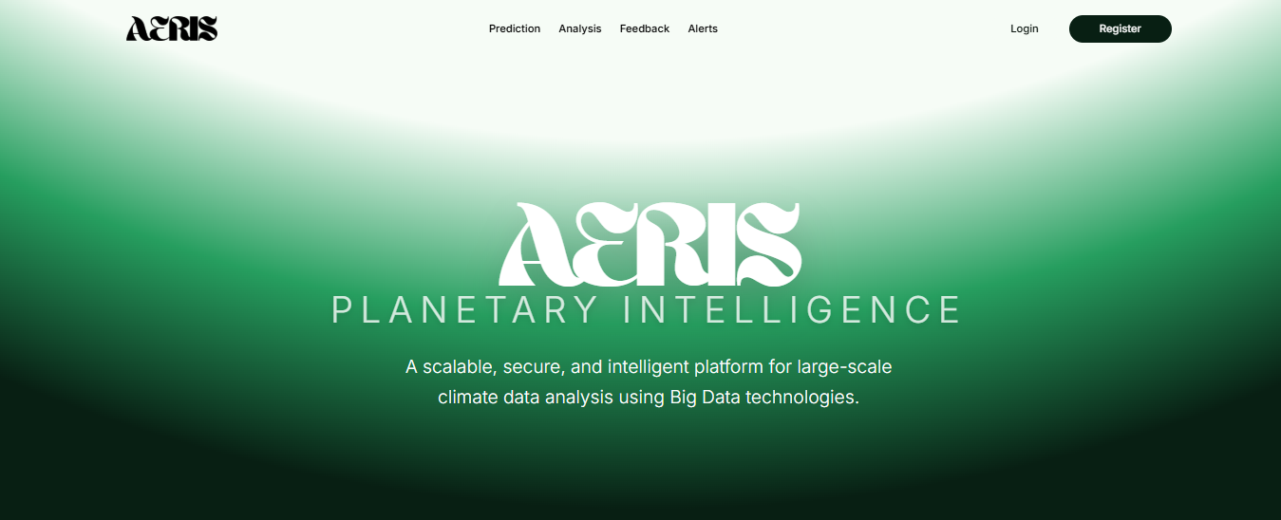
LOGIN PAGE
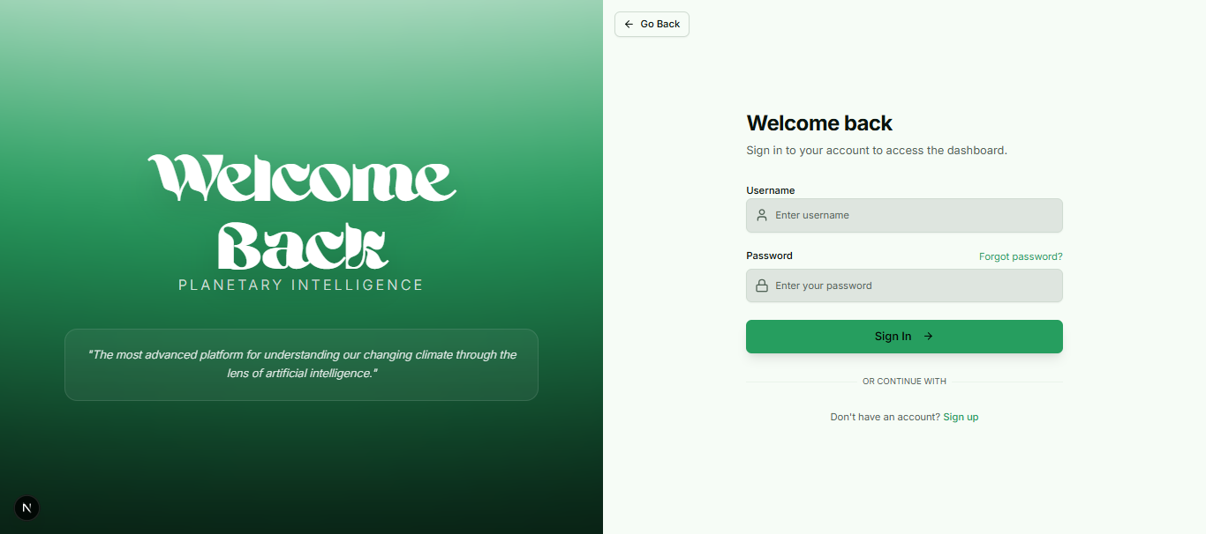
REGISTER PAGE


PREDICTION PAGE
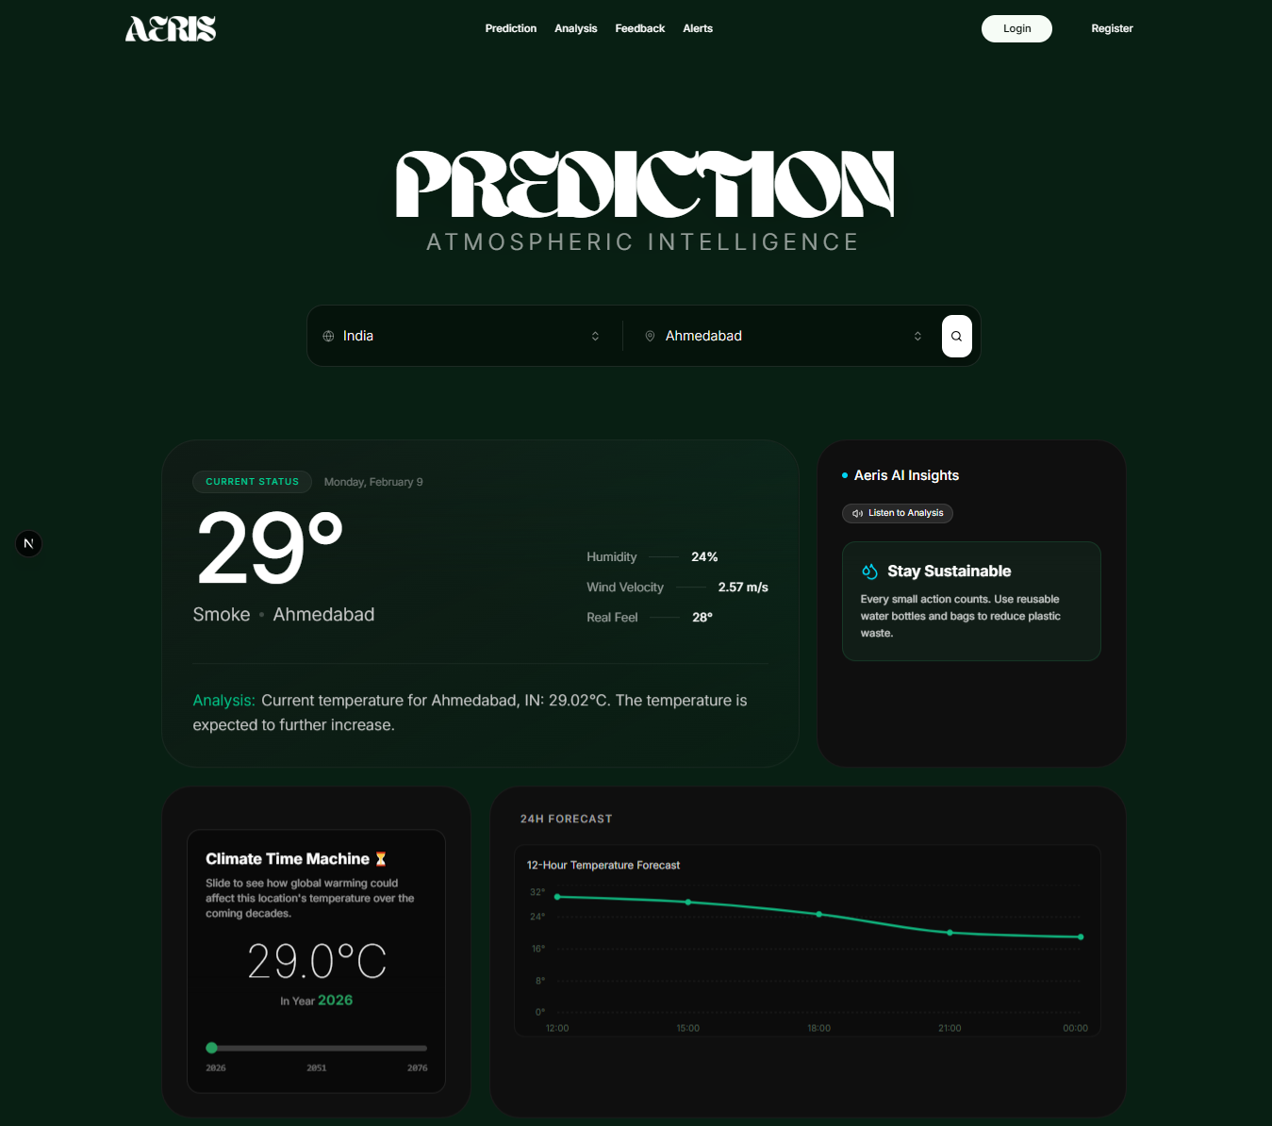
ANALYSIS PAGE
ANALYTICS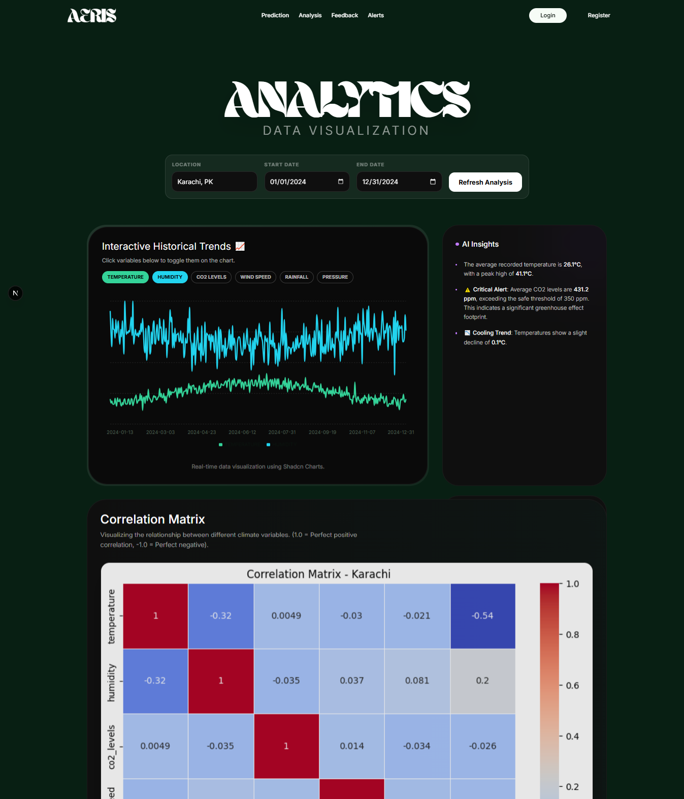
FEEBACK PAGE

ALERT PAGE

SYSTEM ARCHITECTURE

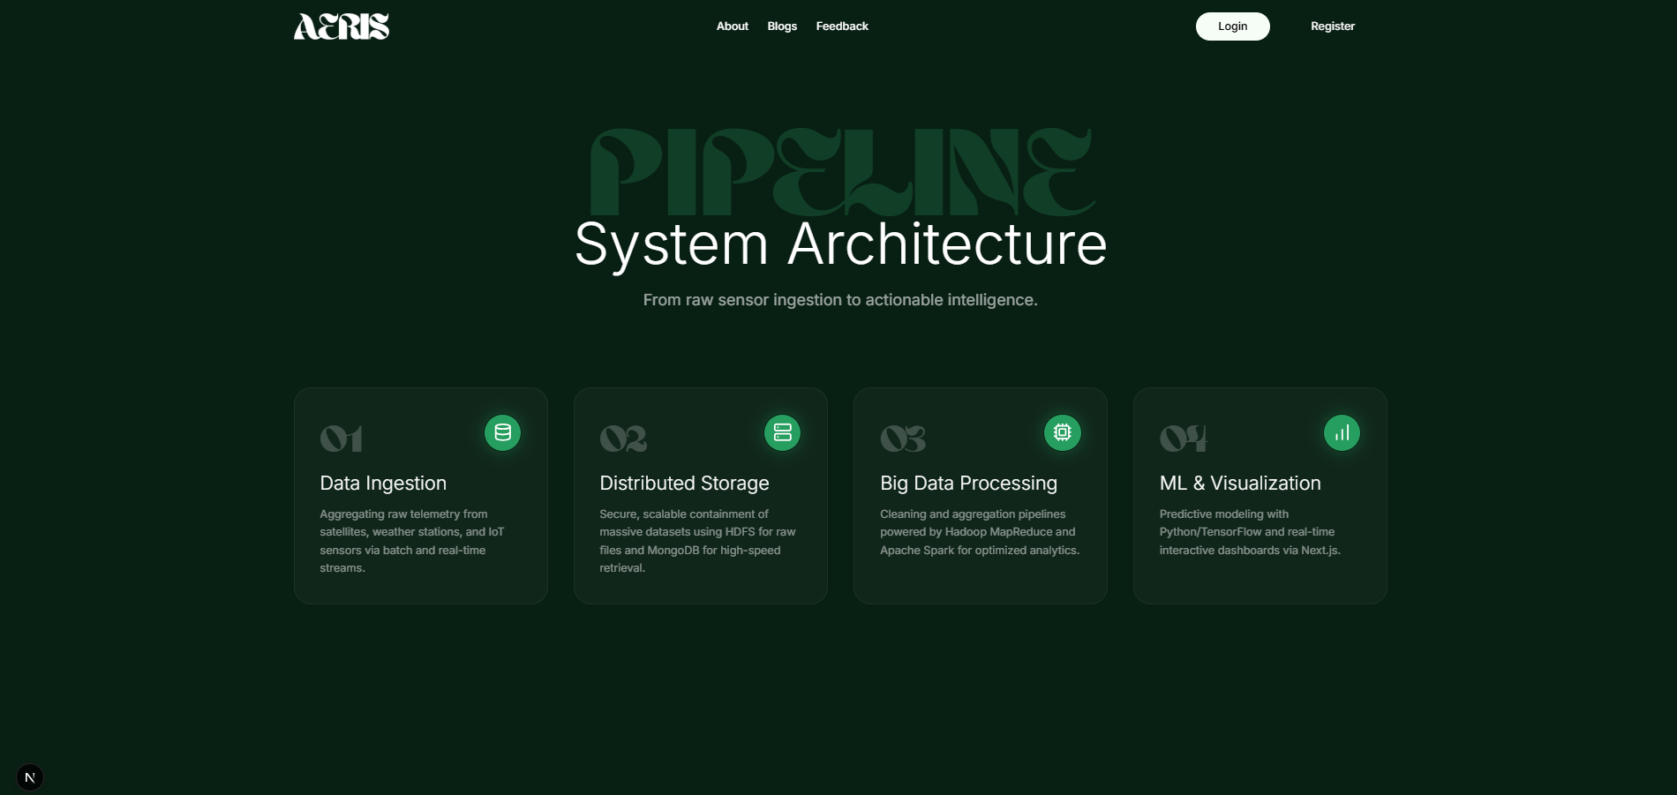

TECHNICAL SPECIFICATIONS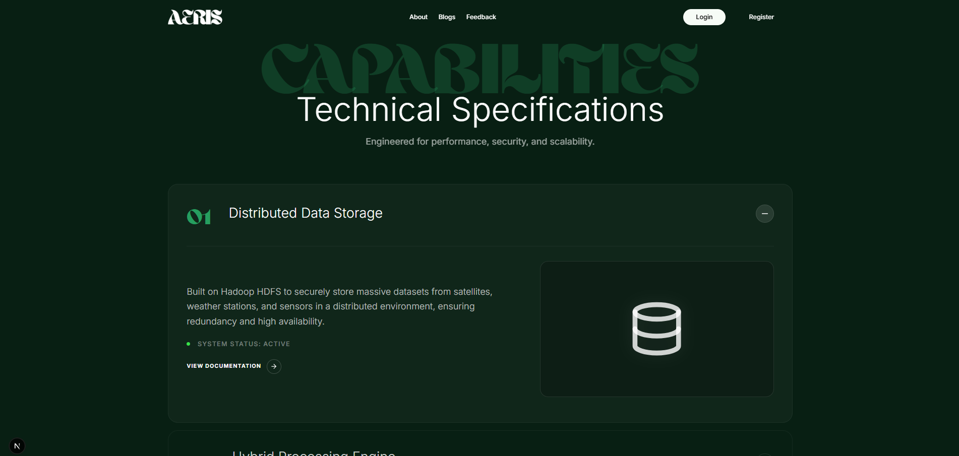

SYSTEM STATUS

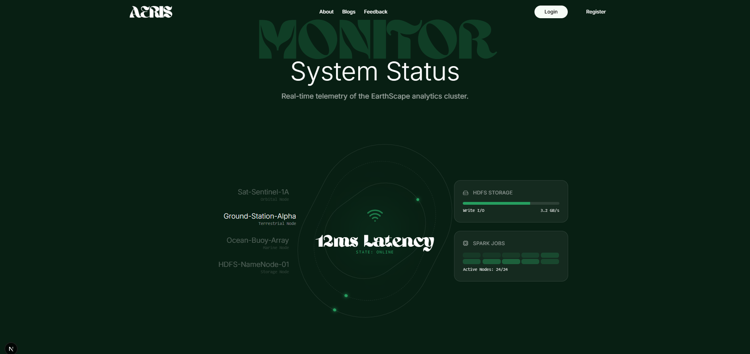

OUR MISSION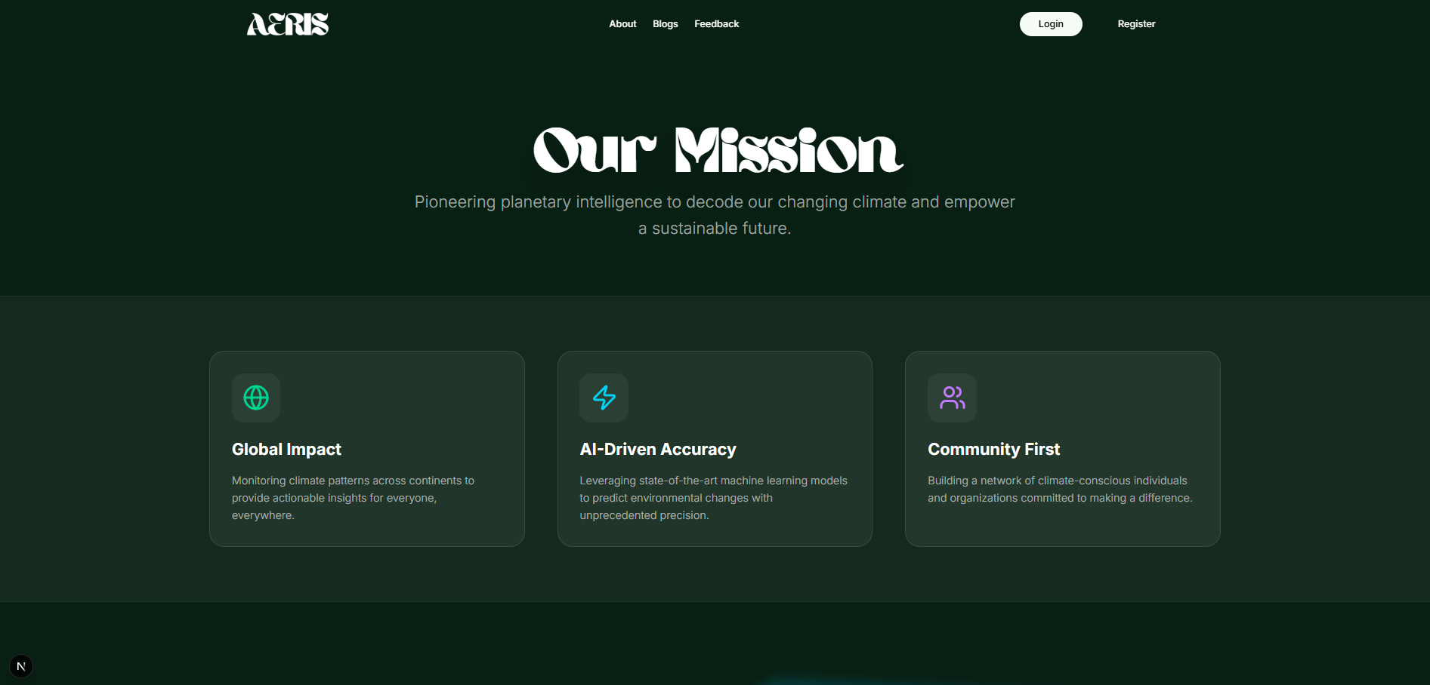

FEEDBACK


ALERTS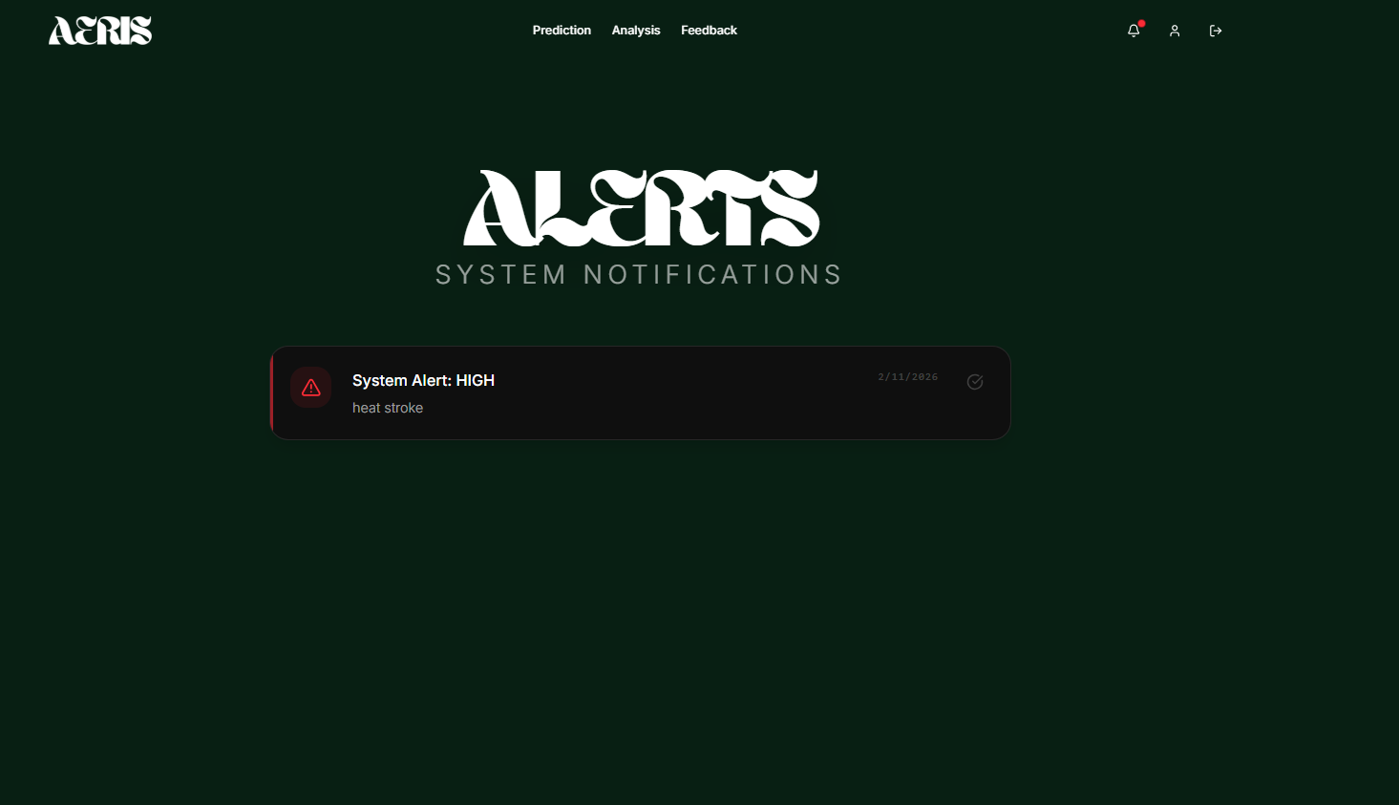

LOGIN PAGE
INSIGHTS
